BlossomGifts – Online Gift Shop
Project: BlossomGifts | Technology: HTML, CSS, JavaScript (localStorage)

Aim
To build an online gift and flower shop with category browsing, cart, wish list, reviews and order management.

Algorithm
- Start: load items, users, orders, carts and wish lists.
- Display categories and recommended gifts.
- Search/sort items; view details and reviews.
- Add to cart / wish list; adjust quantity; remove lines.
- Checkout creates order and reduces stock.
- Admin manages gifts and order status.
- Save to localStorage. Stop.

Result
The BlossomGifts – Online Gift Shop was implemented successfully using HTML, CSS and JavaScript. All modules (login, role-based pages, data entry, search/booking and admin management) work correctly in the browser, and data persists using localStorage.

Implementation (Output Screenshots)
Home page
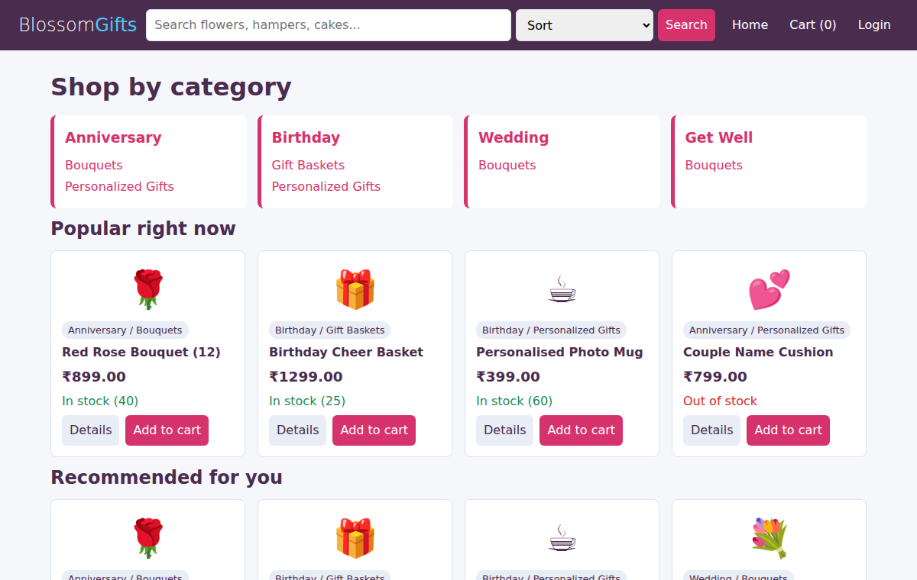
After login (admin / dashboard)
